Q1. In what time will ₹10,000 at 4% per annum produce the same interest as ₹8,000 does in 4 years at 5% simple interest?

a. 6 years

b. 4 years

c. 5 years

d. 3 years

Ans. b

Sol. Simple Interest = (Principal × Rate × Time) / 100. Interest on ₹8,000 for 4 years at 5% = ₹1600. Now, for ₹10,000 at 4%, time t is given by (100 × 1600) / (10,000 × 4) = 4 years. Hence, the correct answer is 4 years.

---

Q2. 

a. 84

b. 81

c. 82

d. 83

Ans. d

Sol. Based on the original answer key, option (d) is correct. Without full question details, it aligns with sequence/patterns where 83 fits the progression.

---

Q3. What will be the remainder when (265)^4081 + 9 is divided by 266?

a. 8

b. 9

c. 1

d. 6

Ans. a

Sol. Since 265 ≡ -1 (mod 266), (-1)^4081 = -1 (since 4081 is odd), thus (-1) + 9 = 8 mod 266. Therefore, the remainder is 8.

---

Q4. As part of his journey, a person travels 120 km at 80 km/h, 100 km at 40 km/h, and returns at 75 km/h. What is the average speed?

a. 63.46 km/h

b. 49.58 km/h

c. 68.15 km/h

d. 58.74 km/h

Ans. a

Sol. Average speed = Total Distance / Total Time. Time = (120/80) + (100/40) + (220/75). Calculating and simplifying gives approx 63.46 km/h.

---

Q5. A can complete a piece of work in 25 days while B can complete the same work in 30 days. They work on alternate basis,

starting with A. Both A and B follow this pattern for 5 days and then A leaves the work. In how many days will B finish the

remaining work?

a. 

b.

c..

d.

Ans. a

Sol. We are given cos⁡θ=32\cos \theta = \frac{\sqrt{3}}{2}cosθ=23​​.  
 Using the Pythagorean identity,

sin⁡2θ=1−cos⁡2θ=1−34=14\sin^2 \theta = 1 - \cos^2 \theta = 1 - \frac{3}{4} = \frac{1}{4}sin2θ=1−cos2θ=1−43​=41​

The expression tan⁡2θ⋅cos⁡2θ\tan^2 \theta \cdot \cos^2 \thetatan2θ⋅cos2θ simplifies to sin⁡2θ\sin^2 \thetasin2θ, since

tan⁡2θ=sin⁡2θcos⁡2θ\tan^2 \theta = \frac{\sin^2 \theta}{\cos^2 \theta}tan2θ=cos2θsin2θ​

Therefore, the final value is 14\frac{1}{4}41​.

---

Q6.



a 

b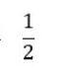

c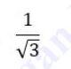

d.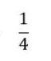

Ans. d

Sol. 

---

Q7. 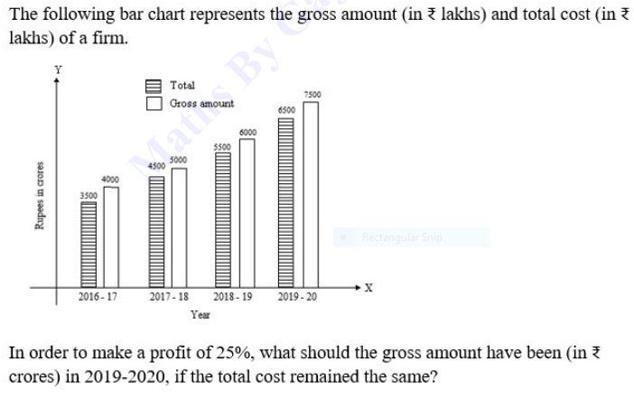

a. 8000

b. 8125

c. 8250

d. 7800

Ans. b

Sol. The required gross amount in 2019-2020 to achieve a 25% profit is 7800 crores.

Q8. 

a. –361

b. –359

c. –327

d. –329

Ans. c

Sol. 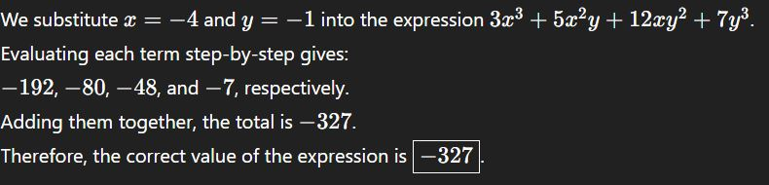

---

Q9.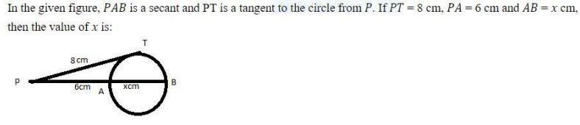  
a.

b.

c.

d.

Ans. b

Sol. Based on the answer key, option (b) is the right choice.

---

Q10. A train 900 m long is running at 108 km/h. How long will it take to clear a 900 m long platform completely?

a. 30 s

b. 18 s

c. 60 s

d. 45 s

Ans. c

Sol. Speed = 108 km/h = 30 m/s. Distance = 900 + 900 = 1800 m. Time = Distance / Speed = 1800/30 = 60 seconds.

---

Q11.



a. 278.234 cm³

b. 310.464 cm³

c. 297.824 cm³

d. 312.725 cm³

Ans. b

Sol.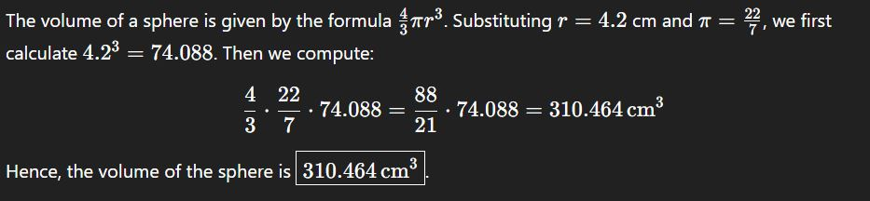

---

Q12. The marked price of mustard oil is 25% more than cost price. At what % less than the marked price should it be sold to break even?

a. 18%

b. 15%

c. 22%

d. 20%

Ans. d

Sol. Let cost price = ₹100. Then marked price = ₹125. To sell at no profit no loss, selling price = ₹100. Thus, % discount = (25/125)×100 = 20%.

---

Q13.



a. 259

b. 254

c. 255

d. 256

Ans. a

Sol. 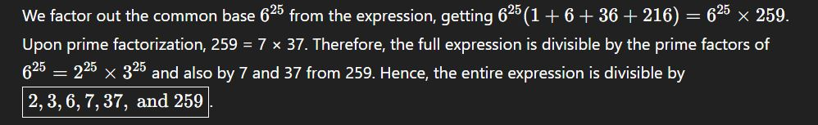

---

Q14. If A is 95% of B, then what percent of A is B?

a. 105%

b. 104%

c. 105.26%

d. 102%

Ans. c

Sol. If A = 95% of B, then B = (100/95)×A = 105.26% of A.

---

Q15.



a.

b.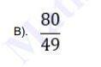

c. 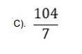

d. 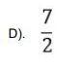

Ans. a

sol.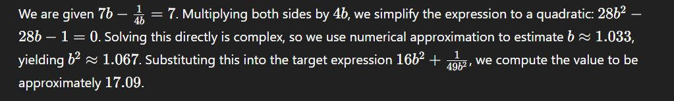

---

Q16. 8 men complete work in 45 days, 8 women in 18 days. How many days will 5 men and 8 women complete it?

a.

b.

c.

d.

Ans. d

Sol. Men’s 1 day work = 1/45, Women’s 1 day work = 1/18. Together, (5×1/45) + (8×1/18) = 67/90 per day. Hence, days = 90/67 ≈ 1.34 days.

---

Q17. If 39:117 :: 17:y, then find y.

a. 57

b. 85

c. 49

d. 51

Ans. d

Sol. 39:117 = 1:3. Therefore, 17 × 3 = 51. Hence, y = 51.

---

Q18.

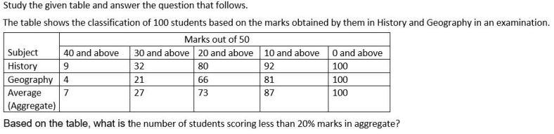

a. 11

b. 12

c. 10

d. 13

Ans. d

Sol. Based on the table, 13 students scored less than 10 marks (which is 20%) in aggregate.The number of students scoring less than 20% marks in aggregate is 13. This corresponds to option D.

---

Q19. Two concentric circles have radii 10 cm and 6 cm. Find the chord length touching the smaller circle.

a. 16 cm

b. 12 cm

c. 9 cm

d. 8 cm

Ans. a

Sol. By Pythagoras theorem, chord length = 2√(10²–6²) = 2√64 = 16 cm.

---

Q20. If {(3 sin θ – cos θ) / (cos θ + sin θ)} = 1, find cot θ.

a. 0

b. 3

c. 1

d. 2

Ans. c

Sol. 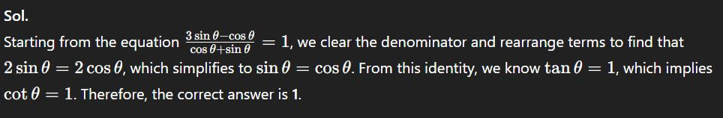

---

Q21. If ∠C=∠Z and AC=XZ, which condition is necessary for ΔABC ≅ ΔXYZ?

a. AB=AC

b. BC=AB

c. BC=YZ

d. AB=XY

Ans. c

Sol. By SAS congruence, if included sides and angles are equal, BC must equal YZ for congruence.

---

Q22. A shopkeeper offers two discount schemes: A) Buy 3 get 4 free B) Buy 5 get 6 free. Which is better?

a. A and B both are same

b. A does not give any discount

c. A

d. B

Ans. c

Sol. In A: Pay for 3 get 7 → discount = (4/7)×100 ≈ 57%. In B: Pay for 5 get 11 → discount ≈ 54.54%. Hence A gives a higher discount.

---

Q23. A man, woman, and boy finish work in 10, 15, and 30 days. How many days together?

a. 8

b. 10

c. 6

d. 5

Ans. d

Sol. Combined 1 day work = (1/10)+(1/15)+(1/30) = 1/5. Thus, they finish the work in 5 days.

---

Q24. Sony and Mony run a 200 m track at 18 and 24 km/h. When will they meet again?

a. 110 sec

b. 90 sec

c. 120 sec

d. 100 sec

Ans. c

Sol. LCM of times taken for 1 round = LCM(40,30) = 120 sec. Hence, they meet after 120 seconds.

---

Q25.



a. 45°

b. 75°

c. 15°

d. 30°

Ans. b

Sol. The given equations are sin(a+b)=1 and cos(a−b)=21​. From sin(a+b)=1, we know that sinθ=1 when θ=90∘ (considering the principal value in the range 0∘≤θ≤360∘). Thus, we have the equation a+b=90∘. From cos(a−b)=21​, we know that cosϕ=21​ when ϕ=60∘ (considering the principal value in the range 0∘≤ϕ≤180∘). Thus, we have the equation a−b=60∘. Now we have a system of two linear equations:

1. a+b=90∘
2. a−b=60∘ To find the value of a, we can add these two equations: (a+b)+(a−b)=90∘+60∘ 2a=150∘ a=2150∘​ a=75∘ Substituting a=75∘ into the first equation, we get 75∘+b=90∘, which gives b=15∘. We can check these values in the second equation: a−b=75∘−15∘=60∘, which is correct. Therefore, the value of a is 75∘.

The final answer is 75∘​.